**INTRODUCTION**

Welcome to the Mississippi Library Commission’s Talking Book Services (TBS). The Library’s goal is to provide you with the best services possible.

Please take time to read the handbook. It will explain how to order and return books, how to operate loaned equipment, and what to do if problems occur. Keep it for future reference.

Mississippi Library Commission is located in Jackson and is responsible for providing talking book library services to individuals who are visually impaired, physically disabled, blind, or have a reading disability due to an organic cause. The collection has the same types of materials as a public library, except the materials have been recorded to a cartridge or formatted into Braille. Additional services include the loan of large print books.

TBS serves as the Mississippi Regional Library for the Library of Congress, National Library Service for the Blind and Print Disabled in Washington, D.C.---the National Talking Book Library. The National Library Service (NLS) established eligibility criteria for the basic talking book and Braille collection, catalogs, and equipment. The Mississippi Library Commission provides the collection’s housing, staff, and other support essential to providing services.

TBS serves all eligible individuals throughout the state and serves all ages. Please contact TBS with any library service related problems.

Correspondence to our library may be directed in a variety of methods.

1. Mail: 3881 Eastwood Drive, Jackson, MS 39211
2. E-mail: [talkingbooks@mlc.lib.ms.us](mailto:talkingbooks@mlc.lib.ms.us)
3. Use of our online library catalog through the website: tbsopac.mlc.lib.ms.us
4. Telephone (statewide and nationally): 1-800-446-0892

Local: (601) 432-4151

Fax: (601) 432-4476

5.The library is open from 8:00 a.m. until 5:00 p.m. Monday through Friday, except State holidays.

If you would prefer all correspondence from the library to come in Braille, please let a reader advisor know.

In addition to books and catalogs, the library’s newsletter will also be mailed to patrons. It contains information of interest concerning any new information or reminders about the digital book machine, audio books, and new book suggestions picked by the TBS staff. The *Reading Light* newsletter is available in Large Print, Braille, PDF, and Microsoft Word.

For all questions regarding the use of equipment, contact the Machine Lending Department at 1-800-446-0892 or 601-432-4151 (local).

**TBS is responsible for the repair of equipment, therefore please report problems promptly and return player when asked to do so.** **Players need to be returned before a replacement player will be sent. A replacement player will be sent as soon as possible. Replacement players are sometimes at a premium and delays may be expected at times.**

**ABOUT TALKING BOOKS . . .**

We have both fiction and non-fiction for all ages. The fiction collection contains many titles in various genres: westerns, mysteries, romances, bestsellers, suspense, science fiction, literature, etc. The non-fiction collection contains biographies, religious works, science, history, health, etc. **The collection does not contain textbooks or other more specialized scholarly materials.**

Talking books are the audio version, word-for-word from the written text. The text is **not edited** at all. This is important to remember if you object to books containing strong language, violence, or explicit descriptions of sex. The annotations in our catalogs do state when any of these three factors are present in our books. If you choose not to receive such books, TBS ***will not*** send them to you. **However, if YOU request a book that does contain strong language, violence, or explicit descriptions of sex, we WILL send it.**

TBS books come in four formats---recorded on digital cartridges, Braille, Large Print, and downloadable books.

**CATALOGS**

A bimonthly catalog called *Talking Book Topics* is available to patrons. Also, patrons can receive a subscription to *Braille Book Review*. These catalogs list the latest books recorded or printed Braille by NLS for patrons. The catalogs are available in large print online at https://www.loc.gov/nls/tbt, on audio, and in Braille. Order sheets are located at the back of each large print catalog and as a separate pullout in the recorded and Braille versions. **WHEN RETURNING BOOK ORDER FORMS IN BRAILLE, PLEASE BE SURE TO INCLUDE YOUR NAME, ADDRESS, AND PERSONAL IDENTIFICATION NUMBER ON THE FORM.**

**TYPES OF SERVICE**

**Online Catalog**

To aid with assurance of quality service, TBS offers several methods to assist patrons with their informational needs. There is a catalog available through the internet. The online catalog is called the TBS WebOPAC (online public access catalog). The WebOPAC enables a patron to search for that favorite author, title, subject, narrator, series, or annotation and then add books to their request list. Use of the WebOPAC exclusions allows you to locate books without explicit descriptions of sex, violence, and strong language if you wish to avoid this material. To search the online catalog and order materials, please call a readers’ advisor to obtain your User ID and personal password.

To access the WebOPAC, simply:

1. Type the address – tbsopac.mlc.lib.ms.us
2. At the top of the page, click on Sign in to place requests or manage your account and enter personal ID and password
3. From this page on, the patron can search and browse the collection
4. Choose all your titles

In addition to the WebOPAC, there are also other ways to receive books from the library:

* A readers' advisor can select books for you based on the patron’s subject preferences.
* Patrons may choose all or a portion of the reading material.

If there are any specific titles or authors you wish to read, these books can be sent to you as well. Please notify a readers’ advisor of your preferences.

Requests for books should be sent to the library by one of the following methods

* Mailing to 3881 Eastwood Drive, Jackson, MS 39211
* E-mail at talkingbooks@mlc.lib.ms.us
* Use of our online library catalog through the Internet at tbsopac.mlc.lib.ms.us
* Telephone (statewide and nationally): 1-800-446-0892

Local: (601) 432-4151

Fax: (601) 432-4476

* Visiting the library from 8:00 a.m. until 5:00 p.m. Monday-

through Friday.

**Please do not send your requests to the Library of Congress, National Library Service for the Blind and Print Disabled in Washington, D.C. or to CMLS in Melbourne, Florida.** They will forward book requests to us, but the delay may be a month or more.

**RECEIVING AND RETURNING BOOKS**

There are different ways to regulate when patrons receive books that have been requested and how many books to receive at a time:

* The simplest way is the "turnaround". This means when a book is returned to the Library. The Library will then send another out.
* A second method is to have books sent only when a patron asks for them---"on demand." This means, however, that no matter how many requests are in a patron’s file, the Library **will not** send a book unless the patron asks that the library do so.

Our new Books-on-Demand (BoD) system has started. This is a system that allows book titles to be copied onto a digital cartridge directly from your request list or from your preferences we have on your profile. We will be able to put multiple books on a cartridge for you more often. Or if you prefer fewer books to a cartridge, we can set that too. You'll be able to have more than one digital cartridge checked out at a time, so you will be able to have books at home while your cartridges are in transit and being reloaded. This system allows you to have multiple titles but fewer cartridges out at once. Your BoD cartridges will arrive in the mail. They will be in a plastic mailing container with one digital cartridge inside. The title of the book will not be on the label on the outside of the container. When you are on the Books-on-Demand model, you can remove the mailing card and just return the book to the library without it.

Materials you are mailing back to TBS should be given to the U.S. Postal Service for return to our library. **No stamps are ever needed when our materials and equipment are mailed "FREE MATTER FOR THE BLIND OR HANDICAPPED" through the U.S. Postal Service.** Letters mailed to our service requesting materials should not be sealed and may be sent without postage through the U.S. Postal Service by writing **“Free Matter for the Blind or Handicapped”** where a stamp would normally be placed.

**LOAN POLICY**

Mississippi Library Commission

Talking Book Service (TBS)

The following policy governs the circulation of books and equipment to eligible blind and/or physically handicapped readers of the Talking Book Service (TBS) of the Mississippi Library Commission (MLC). Eligible readers who borrow materials from TBS accept responsibility for using materials with reasonable care, returning materials to TBS according to established loan policies, and not losing or damaging materials through negligence. Violation of this policy may result in suspension of some or all library service.

**ON LOAN**

**Our book loan period is six weeks.** Before returning the digital books please ensure the digital cartridge matches the name on the outside of the blue digital book container and that the book cartridge is placed in the container Braille side up. If patrons fail to return materials on time, overdue reminders will begin to be sent via the mail.

The Board of Commissioners of the Mississippi Library Commission has adopted the following policy regarding the loan of Library of Congress materials:

**POLICY**

Braille, recorded books, magazines, and specialized playback equipment will be loaned by the Talking Book Services (TBS) to eligible registered readers without charge and TBS will keep records of all such loans. The borrower should notify TBS of changes of address, a desire to cancel the service, or the temporary or permanent transfer of service to another geographic area.

TBS equipment is necessary to play the TBS recorded materials. To keep the equipment, the borrower should be using the equipment to read materials provided by TBS. In the event the machine ceases to function properly or needs repair, **the machine should be returned to TBS**. A replacement machine will be provided. Under no circumstances should a borrower attempt to repair the playback equipment and/or accessories.

The borrower will ensure that books, magazines, and equipment being returned to the Talking Book Services as "Free Matter for the Blind or Handicapped" are delivered into the hands of the United States Postal Service by placing the material in a mailbox or by delivering the items to the post office. Placing items on the doorstep of the borrower's home for the mail carrier to pick up does not constitute delivery into the hands of the postal service and if problems arise by use of this method, the borrower is responsible for lost or damaged materials.

**Borrowers may NOT lend TBS books, magazines, or equipment to other persons.**

**SUSPENSION PROCEDURES**

In the event any of these policies are repeatedly violated, the borrowers' service may be suspended for a period of time, not exceeding six (6) months. If, after suspension of service, policies continue to be violated, service may again be suspended.

Approved by the National Library Service for the Blind and Physically Handicapped June 9, 1988.

Adopted by the Mississippi Library Commission Board of Commissioners September 23, 1988.

Distribution: Current patrons and new patron packets.

Format: Large Print, Braille and digital cartridge.



***PROBLEMS?***

Each incoming digital cartridge is checked to see if there are any problems. The library checks each digital cartridge to make sure they are returned in the proper containers.

In addition, there will sometimes be a problem with a cartridge that cannot be found just by looking at it. If a patron does receive a defective book, please notify the Library. Or you can make an X in the box next to **Defective Book** on the return address label so we can identify it when it is returned. **Please do not enclose notes in your books as this is against postal regulations.** The Library can also send you a replacement copy if we have one readily available.

**Large Print Direct Mail Service**

We offer Large Print Service. Special catalogs will be sent with titles and annotations. At the back of each catalog there is an order form to fill out and place in the envelope provided. There is also an additional list of previous large print catalogs that may be ordered on that form. These catalogs do not specify if the books contain sex, language or violence.

Only three large print books will be sent initially but this number may be increased if needed. Please keep a few books on your request list so when a book is returned another will be sent to you. The loan period for large print books is six weeks. Additional information will be included in your large print catalog.

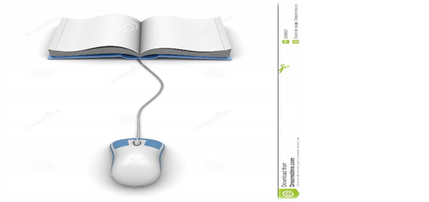

BARD Information

BARD is an acronym for “Braille and Audio Reading Download.”  Braille Audio Reading Download (BARD) is a program offered by the National Library Service and Braille Institute Library. This free program allows patrons to download talking books from an extensive collection of titles.

To use BARD, a TBS patron must have a library account and obtain an account at the BARD website. Once you have an account, you can download the books to a USB storage device and play them on your digital talking book player. For more information on BARD, the BARD website is: [https://nlsbard.loc.gov](https://nlsbard.loc.gov/cgi-bin/nlsbardprod/index.cgi)

If you have any questions, call the Talking Book service dept. at 800-446-0892 or e-mail us at talkingbooks@mlc.lib.ms.us.

**MAGAZINES**

A variety of magazines are available as free subscriptions through the National Library Service on digital cartridge and in Braille. Some magazines are mailed by TBS and need to be returned when you have finished reading them. Others are sent directly from the producers and need to be returned. They are not to keep.

TBS will handle free subscriptions to magazines for you. Including new subscriptions, changes of address, and cancellations. For direct mail magazines the changes generally take eight to ten weeks. In addition to the magazines available free of charge through the library, a number are also available commercially for a **small subscription cost**. These are usually more specialized magazines and include several religious periodicals. Ask TBS for a complete listing. Those available free of charge through TBS are listed in each edition of *Talking Book Topics*.

**FREE MATTER MAILING PRIVILEGES**

Since 1904, U.S. law has stated that library materials for the blind and handicapped may be sent "**FREE MATTER FOR THE BLIND AND HANDICAPPED**." This is written in the area where the stamp would be placed on materials sent to you. It is also on the reverse side of the mailing labels used to send books, equipment and magazines back to us.

A recent revision of the postal code makes it necessary for some individuals to register with their local post offices to take advantage of **"FREE** **MATTER"** mailing privileges. Not everyone has to register if their local postmaster has specific knowledge of your visual or physical disability. Contact TBS or your postmaster if you have any questions concerning postal regulations.

The following tips may be useful. Items allowed to be mailed **"FREE** **MATTER"** include talking books, Braille books, large print books catalogs, TBS newsletter, and the equipment loaned to you.

Your postman is required to deliver your talking books and equipment. He or she is **NOT** required to pick them up at your house. If the talking books cannot fit into your mailbox, be sure to discuss the problem with your mail carrier. Most of them are very cooperative and something can usually be worked out. Call the Talking Books Service department if you are having problems with your mail carrier.

**Do not pay postage to mail books or equipment back to us. All of our materials can be mailed FREE MATTER.**

**CHANGES AFFECTING**

**SERVICE**

Let the Library and the Post Office know if you are going out of town for a long period of time. Otherwise materials will be returned "refused" and the library will think you are canceling your service. The library can hold materials at the library, but catalogs and magazines come from a central mail location for the entire United States and must be held at the local post office.



Every state has a talking book library. If a patron is permanently moving out of state, there are a few steps that need to be taken:

* Is the patron going to take equipment with them? (The Patron needs to notify the state they are moving from either way).
* Any books borrowed needs to be returned to the library they were borrowed from.
* The old lending library will transfer your records to your new state lending library.
* Please give old state lending library advance notification, as well as forwarding address and phone number.

**EQUIPMENT**

**TBS** **LOANS** the equipment free of charge, but the patron must be an active user of the library service to keep the equipment on loan. If the patrons do not use the service within a year, the patron will be asked to return the equipment. One year of dormant circulation on a patron’s account classifies that patron as “inactive.” The equipment is the property of the federal government and is not to be disposed of in any way other than by returning it directly to the Talking Book Services (In some places you can return equipment to your local public library and the library will return the equipment to Talking Book Service.

**Please keep the following in mind:**

* **You must be an active user of TBS to keep equipment on loan.**
* **The equipment is the property of the federal government and is ON LOAN to you.**
* **You may only dispose of the equipment by returning it to the Talking Book Services.**
* **Keep the box in which the equipment is sent. If there are problems with the digital players, please use this box to return the equipment to us.**
* **The equipment may only be repaired at government authorized repair centers (Send to TBS).**

Currently, all equipment boxes have a clear plastic sleeve for insertion of mailing labels addressed to patrons. To return equipment in a box with the plastic sleeve, simply remove the label used to mail the equipment to you from the sleeve. The TBS mailing address is under the clear plastic sleeve for your convenience. After these steps have been followed, seal the box closed and mail the equipment **"FREE MATTER"** to us. **Please do not use duct tape to seal the box.**

|  |  |  |
| --- | --- | --- |
|  | **DO NOT ATTEMPT TO REPAIR, OR HAVE REPAIRED, ANY EQUIPMENT ON LOAN TO YOU** |  |
|  | ***and***  **RETURN EQUIPMENT NEEDING REPAIR TO TALKING BOOK SERVICES** |  |

**When you receive your digital player a return machine form will be inside for whenever the machine need to be returned. Replacements will not be automatically sent to you. When the time comes to send your machine back pick one of the choices on the form to let us know what you would like use to do. If this is not done it can delay the replacement of your machine by several days. Please keep the box the machine comes in.**

**EQUIPMENT INSTRUCTIONS**

**DIGITAL PLAYERS:**

The digital player will come with recorded instructions loaded into the player. Use the diagrams and written instructions on the pages to supplement knowledge of the equipment. Should you have any further questions, please feel free to call the library.

***Digital Standard Players***

***The Standard Model (DS1)***



*The user operates the player using buttons located on the top of the machine. In addition, several player functions occur automatically in response to patron actions or inactions. The player automatically powers on and gives an audible greeting when the patron plugs the player cord into a live AC power outlet. When powered on, (which means pushing the RED button), the player will start or resume playing your digital book when the cartridge is inserted into the player.*

***The Digital Advanced Player (DA1)***



*The advanced model has an additional row of controls between the raised line and round speaker. The advanced controls are for setting and retrieving bookmarks and for navigating through the structured levels of books. A helpful step is the process of navigating between multiple books on a USB drive. First, place the flash drive into the port and press and hold the play/stop button until the book shelf*

*opens. Then press either the left or right buttons to pick a book. This process may be done on either the standard or the advanced player.*

**USB FLASH CARTRIDGE**

**(Digital Book)**

**The cartridge has mechanical features that aid is handling by an individual with disabilities or limited manual dexterity. The cartridge can be inserted into the player in only one direction, Braille side up.**

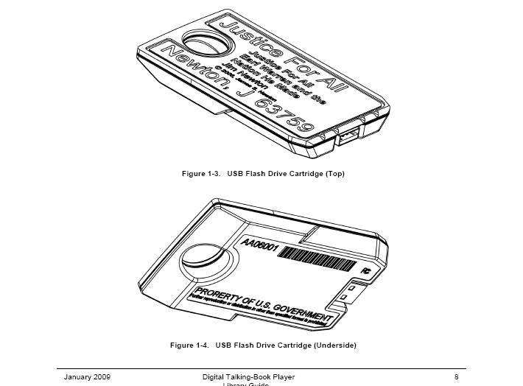

 headphone adapter (stock number

**Digital Talking Book Machine**

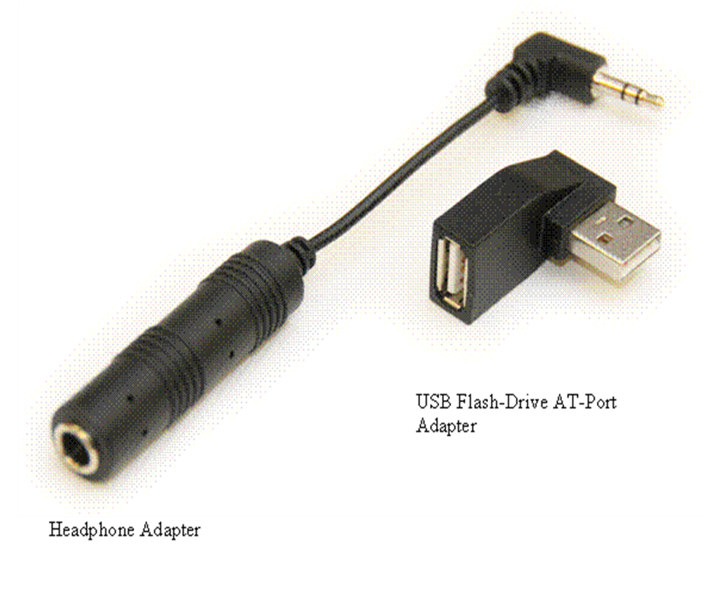**Accessories**

**Please note:**

**When first starting to play a talking book machine there may be as much asONE MINUTE OF SILENCEbefore the narration begins.**



***EQUIPMENT ACCESSORIES***

Several accessories are available for use with the digital DS1 and DA1 players. The following are available through TBS. These accessories may be requested when you begin the talking book service or added later as you may have need for them. Please note that these accessories are only available as qualities allow.

* + 1. **USB FLASH DRIVE ADAPTERS** allow the user to plug a flash drive into the digital machine port at a 90-degree angle to the built-in connecter. Orientating the external USB drive along the side of the figural machine reduces the potential for damage to the drive and machine.
    2. **HEADPHONES** are available only to those patrons who must use headphones to use the service. Some eligible patrons are those in institutions, schools, and/or other community living situations. Other eligible patrons include those that experience a hearing loss that would hinder their using the talking book library service. Similar headphones are available from a variety of commercial outlets. Take your player with you to be sure of an exact fit. Headphones do not need to be returned.
    3. **BREATH SWITCHES** are available for readers with severe physical disabilities who have little or no use of their extremities. The breath switch plugs into the remote-control transmitter and uses air pressure to operate only the on or off functions of the equipment. For more information on obtaining this switch, please contact the library.
    4. **PILLOWPHONES**, to be placed under the readers pillow, or for those patrons with disabilities who are bedridden. The sound normally can be heard only by the reader. The pillow phone can be plugged into a jack on the side of NLS equipment.

**ADDITIONAL SERVICES**

**BIBLES**. Many patrons are interested in having their own copy of the Bible. For a list of sources, please contact us.

**MUSIC.** A music collection is not available through this TBS Library, however, for the serious musician, the Library of Congress offers instructional type materials.

**NLS Web site.** The Web site for the National Library Service for the Blind and Print Disabled, a division of the Library of

Congress, may be accessed at http://www.loc.gov/nls

**NFB-NEWSLINE.** The National Library Service for the Blind and Print Disabled (NLS) and its network of cooperating libraries are working with the National Federation of the Blind (NFB) to make new NLS patrons and other eligible individuals aware of NFB-NEWLINE. This service is available 24 hours a day, 7 days a week and is free to anyone who is eligible. Daily papers which include the Jackson Clarion-Ledger, Memphis Commercial Appeal, the Biloxi Sun-Herald, USA Today, the Chicago Tribune, the New York Times, the Washington Post, the Los Angeles Times, the Wall Street Journal and others are heard over the phone in a synthetic voice. You will be given an ID

number and security code by a sponsoring agency in Mississippi to access this service. For more information call a Reader’s Advisor.

**RADIO READING SERVICE.** This service provides current information on the radio 24-hours-a-day for individuals who are unable to read the printed word. It features over 60 magazines, 6 newspapers and more than 168 hours each week of short stories and books as well as selections from the Bible. A special radio that is permanently tuned to the RRSM channel is sent free of charge to qualified individuals. For an application, contact:

Radio Reading Service of Mississippi

3825 Ridgewood Road

Jackson, MS 39211

Telephone: **(601) 432-6301**

Visit the Radio Reading Service web site at:

www.mpbonline.org

***PUBLIC LIBRARIES***

Most public libraries will accept machines to be shipped back to the library (TBS) but please use this option as a last resort. The post office will be happy to ship the players back without any postage needed.

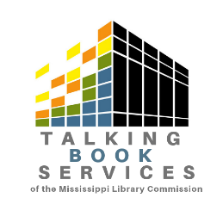**Mississippi Library Commission Free Matter for the Blind**

**Talking Book Services & Physically Handicapped**

**3881 Eastwood Drive**

**Jackson, MS 39211**



**X**

That All May Read

STRING LOGO.png

**Email:** [**Talkingbooks@mlc.lib.ms.us**](mailto:Talkingbooks@mlc.lib.ms.us)

**Toll-free: 800.446.0892 FAX: 601.432.4476**

**WebOPAC: tbsopac.mlc.lib.ms.us (Online card catalog)**

|  |  |  |
| --- | --- | --- |
| **Patron Services Coordinator** | **JD** | **601.432.4140** |
| **Patron Services Librarian** | **Margaret** | **601.432.4095** |
| **Patron Services Librarian** | **Evan** | **601.432.4128** |
| **Patron Access Librarian** | **Riley** | **601.432.4126** |
| **Large Print Direct Librarian** | **Gloria** | **601.432.4047** |

**This publication is partially funded under the federal Library Services and Technology Act administered by the Mississippi Library Commission for the Institute of Museum and Library Services**