Style Guide

<insert image of library>

<Date>

Why a style guide? A strong style guide is a necessary tool for creating brand identification. A brand style guide serves as a crucial manual that enables content producers to convey a unified message to their audience.
A style guide also supports your marketing efforts and strategic communication by keeping your libraries branding relevant and connected to your strategic goals. By keeping your branding consistent, it will help raise awareness of your library brand and foster trust over time.
Please refer to this document for standards when creating written communications, publications or graphics for the <insert library name>. This will create a strong and consistent message in everything you do.

<who do they consult with questions? Insert here>

About the <library name>

<insert summary about the library. This is your ‘verbal identity’ and can be used like an ‘elevator pitch.’ >

Mission:

Vision:

Core Values:

tagline/slogan

<Does your library have a slogan? Your slogan should be short and memorable and should relate to the mission of your library.>

Tagline

logo
<Insert logo image here>
<Does your logo have special meaning? Is there a story there?>

Logo Variations
<Logo variations are approved color variations such as grayscale, black and white and other branded colors. It could also include other types of variations such as gifs of the logo, vertical vs horizontal layouts, and abbreviations.>
<How and where should the Logo be used>
- Do not distort the logo when resizing
- Do not make the logo so small it is unreadable
- Do not change colors on the log beyond what is on file
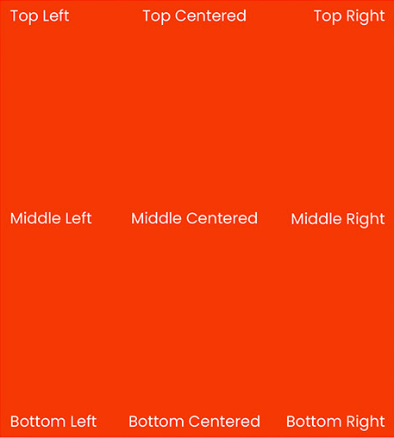

colors

<insert color palatte image>

Your color palatte is your library’s chosen colors that are used in your logo and beyond. Be sure to include technical color descriptors such as Hex, Pantone (PMS), or RBG. Some brands even have a color philosophy on why they chose their colors.

You can use Canva or Photoshop to help find the technical color codes or these websites:
https://www.rapidtables.com/web/color/RGB_Color.html
https://www.pantone.com/pantone-connect
https://marketing.istockphoto.com/blog/hex-colors-guide/

Typography

<What fonts do you want to officially be used for your publications? What font is used for your logo? If you are not sure, what fonts do you NOT want used?>

HEADLINES:
TEXT COPY:

Here are some websites to help match up fonts:
https://www.creativebloq.com/typography/20-perfect-type-pairings-3132120
https://www.fiverr.com/resources/guides/graphic-design/how-to-choose-font-for-logo
https://www.canva.com/learn/the-ultimate-guide-to-font-pairing/

Email Signatures

<Consistent email signatures adds a professional look to correspondence. Additional information can be placed at the end of signature to highlight your website, social media or even important upcoming events. Just don’t forget to update it!>

Example:
Kristina Kelly | Public Relations Coordinator
Mississippi Library Commission
3881 Eastwood Drive
Jackson, MS 39211
601·432·4157
www.mlc.lib.ms.us
Connect with the Mississippi Library Commission:

Stationary

Business Cards

Example of Library Business Card: <Insert image of business card>

How to Order: <Insert full contact information >

How to request new cards: <Insert procedure for ordering>
Description of materials: <glossy, matte, size, layout, etc.>

Letterhead, envelopes, etc.

<Repeat for each piece such as envelope, letter head, any other correspondence>
<Insert image of each piece for reference as detailed ordering information>
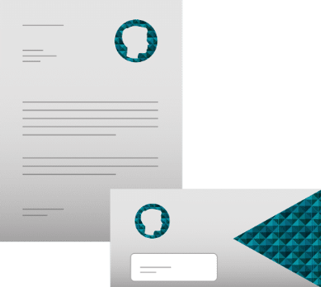
Example:

Size: <insert size of each letterhead, envelope, etc>
Material: <weight of paper,type, etc.>
Where to order: <insert full contact information>

