Web Cameras and Microphone
Many web-cams costs range from $30 to $100 with specialty web-cams exceeding $100.
The web camera that MLC will be utilizing is the Logitech C270 with built-in Mic for $39.99.
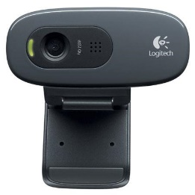
Logitech C270 Webcam - Black - USB 2.0 - 1 Pack(s) - 3 Megapixel
Interpolated - 1280 x 720 Video - Widescreen - Microphone

