Wi-Fi Extenders, Boosters, Range Extenders, Repeaters basically serve the same purpose of delivering Wi-Fi to a specific area. Extenders a usually more compact and plug into an electrical outlet while repeaters are wired. The best use of each will depend on the environment to receive Wi-Fi.

A general-purpose extender: $40

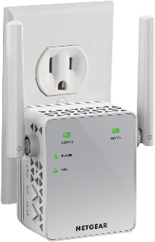

NETGEAR Wi-Fi Range Extender EX3700 - Coverage up to 1000 sq.ft. and 15 devices with AC750 Dual Band Wireless Signal Booster & Repeater (up to 750Mbps speed), and Compact Wall Plug Design

https://www.amazon.com/NETGEAR-Wi-Fi-Range-Extender-EX3700/dp/B00R92CL5E/ref=sr_1_14?dchild=1&keywords=outdoor+wifi+extender&qid=1589557082&sr=8-14

This extender is super simple to set up and will push the signal an additional 1000 square feet. There are several different brands of these, Netgear and TP Link. These work equally well. Placed on an interior wall next to a courtyard or patio, the signal could cover those areas while keeping the extender protected from weather and secure.

A general-purpose outdoor transmitter: $50

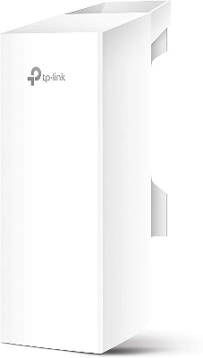

TP-Link Long Range Outdoor Wi-Fi Transmitter – 5GHz, 300Mbps, High Gain Mimo Antenna, 15km+ Point to Point Wireless Transmission, Poe Powered W/ Free Poe Adapter, Wisp Mode(Cpe510)

https://www.amazon.com/dp/B00N2RO63U/ref=twister_B081R1R6VF?_encoding=UTF8&psc=1

This outdoor extender would be put on the wall outside to cover a specific area. Additional considerations are the expense of cable installation and suppling power over ethernet (POE, power is run through the network cable).

