These recommendations for laptops include Low End, Mid-Range, High End. These laptops will be good for libraries dependent on budget and task. Reviews were examined for each of these laptops to see what other people thought of them, problems and for considerable concerns.

Least Expensive:

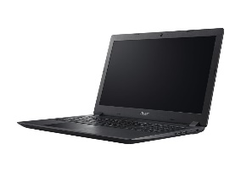

Acer Aspire 3 A315-21-927W - 15.6" - A9 9420e - 6 GB RAM - 1 TB HDD - US In
ACER Aspire 3 that is $366.99. Reviews with the speed and battery life being the main complaints for gamers and high-end users. Reviewers who use the computer for work tend to say that it is a good laptop for the price and, while it’s not the fastest, they are able to do the work they need to do on it.
https://www.cdw.com/product/acer-aspire-3-a315-21-927w-15.6-a9-9420e-6-gb-ram-1-tb-hdd-us-in/5429984?pfm=srh

Mid-Range Price:
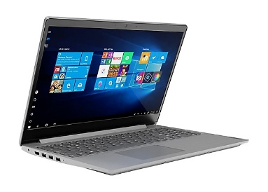

Lenovo V15-ADA - 15.6" - Athlon Gold 3150U - 8 GB RAM - 256 GB SSD - US

Lenovo V15-ADA for $442.99. This laptop has good reviews and the main complaint is that it does not have an onboard LAN connection, meaning it will only run on WiFi.
https://www.cdwg.com/product/lenovo-v15-ada-15.6-athlon-gold-3150u-8-gb-ram-256-gb-ssd-us/6022479
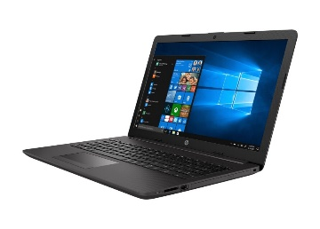

HP Smart Buy 255 G7 15.6" Ryzen 3 2200U 8GB RAM 256GB Windows 10 Pro
HP SmartBuy 250 G7 for $712.99. These have 4 star reviews with the biggest complaint being the quality of the screen.
https://www.cdw.com/product/acer-aspire-3-a315-21-927w-15.6-a9-9420e-6-gb-ram-1-tb-hdd-us-in/5429984?pfm=srh

Higher Range Price:
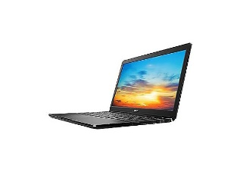
Dell Latitude 3500 - 15.6" - Core i7 8565U - 8 GB RAM - 256 GB SSD

Dell Latitude 3500 for $965.99. Good reviews. Hard drive (256 GB.) Larger hard drive consideration.
https://www.cdw.com/product/dell-latitude-3500-15.6-core-i7-8565u-8-gb-ram-256-gb-ssd/5490817?pfm=srh

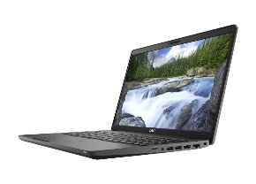

Dell Latitude 5500 - 15.6" - Core i7 8665U - 16 GB RAM - 512 GB SSD
Dell Latitude 5500 for $1,744.99 Good reviews. Highest end recommendation.
https://www.cdw.com/product/dell-latitude-5500-15.6-core-i7-8665u-16-gb-ram-512-gb-ssd/5555988?pfm=srh

