Chromebooks
Chrome books are similar in price. Any of the 5-star rated chrome books would be sufficient libraries general purpose work. Mid-range Chromebook pricing is from $265 to $373.
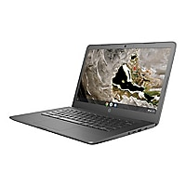

HP SB Chromebook 14A G5 AMD A6 9220C 4GB RAM 32GB Chrome

HP SB Chromebook for $322.99. 14-inch screen

This is a link to all the chrome books on CDW’s site that have 5-star reviews.
https://www.cdw.com/search/Computers/Notebook-Computers/?w=C3&a3407=50713045&enkwrd=chromebook&ln=0&rv=52000005

